**Finding lanes on the Road**

**Goal**

* Make a pipeline that finds lane lines on the road given an image or video as input.

**Reflection**

**Pipeline Description**

Pipeline consists of six steps and they are as follows

1. Convert the image to gray scale.
2. Blur the image using Gaussian Smoothing.
   1. Gaussian Smoothing blur's the image a little bit and gets rid of some of the noise.
   2. We are interested in strong contrasting boundary lines and any noisy ones are not interesting.
   3. Usually used kernel sizes are 3 or 5
3. Find edges using Canny Edge detection algorithm.
4. Extract the region of interest.
   1. Usually the road appears below in the image and does not appear above.
   2. Also, it appears towards the center of the image.
   3. So, extracting relevant portion of image helps us to eliminate all the edges in rest of regions in the image.
5. Apply Hough Transform
   1. The purpose of the technique is to find imperfect instances of objects within a certain class of shapes by a voting procedure.
   2. In this case we are worried about identification of lines in image.
6. Combine lines image with original image

The draw lines function called to draw lines that the Hough transform detects is improved to identify the full extent of the line. If you look at the image, since the origin i.e. (0,0) is in the top left of the image and (image_width, image_height) is in the bottom left of the image, the left lane has negative slope and right lane has positive slope. So, we segregate the points (ends of line segments given by Hough transform) that belongs to left lane and right lane by finding slope and adding them to appropriate lists. Once we segregated the points, we find the average slope for right lane and left lane. We then find intercepts and draw the left lane and right lane respectively.

**Output images without extrapolation:**

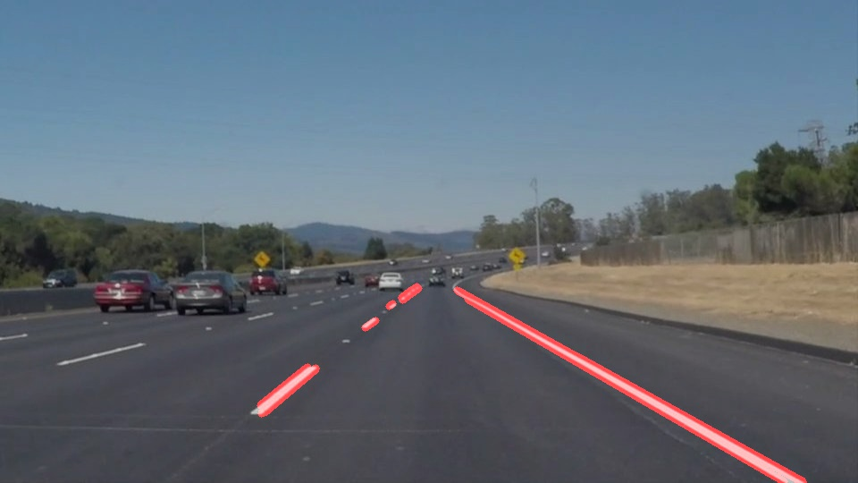

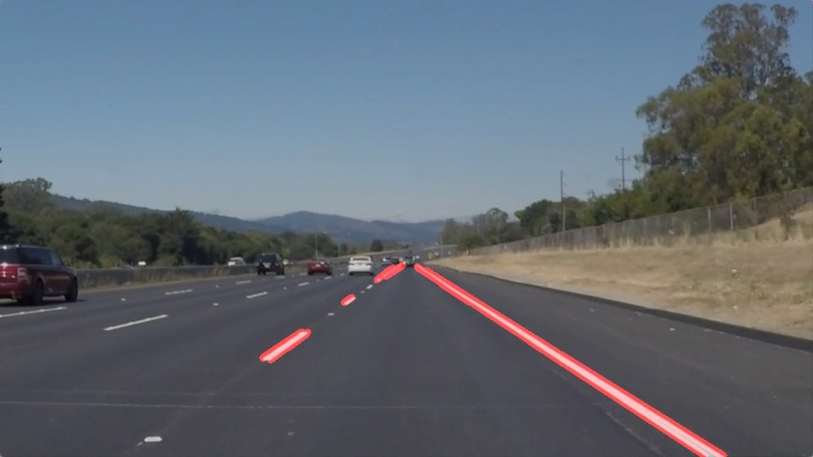

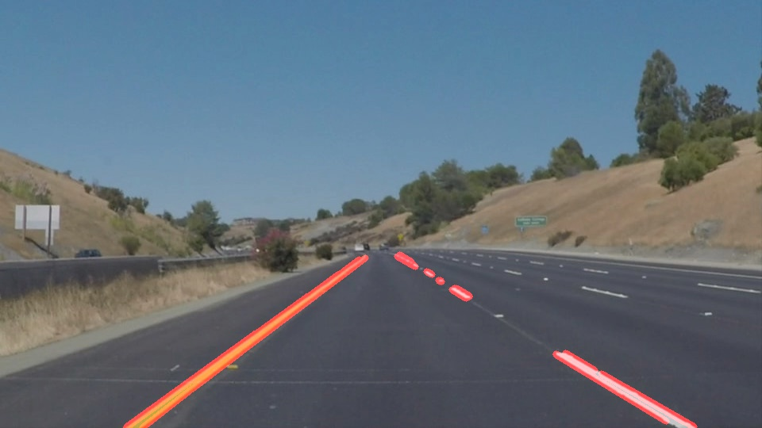

**Output images with improved draw lanes:**

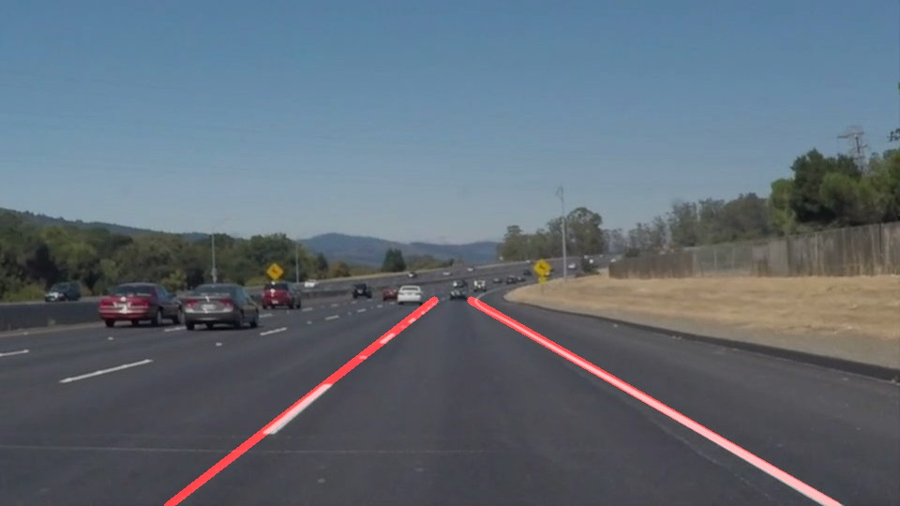

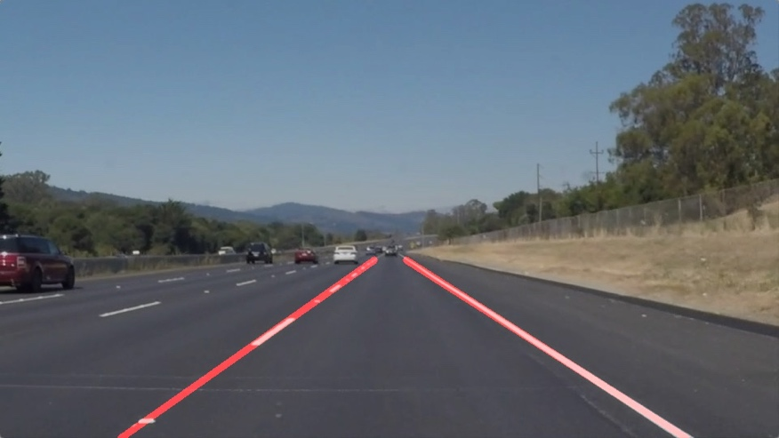

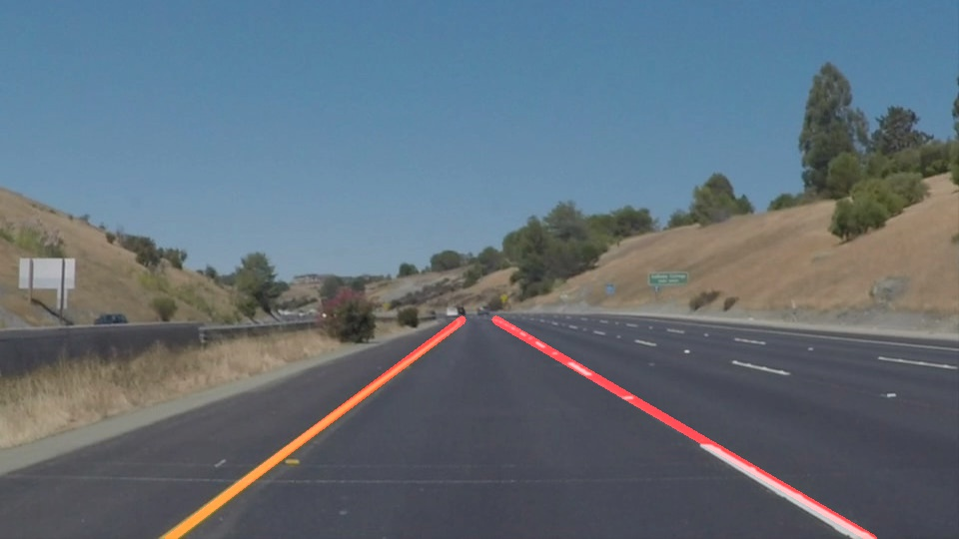

**Shortcomings**

One potential shortcoming would be that since we are trying to draw only one line for each lane, model clearly performs bad in case of dealing with curves.

**Improvements**

Improvement would be to use advanced techniques like histogram peaks and sliding window concepts which we will be learning further in this nanodegree.